ReffRebound Figures

Weihsueh Chiu

2020-07-30

## Load results

## Refft at min

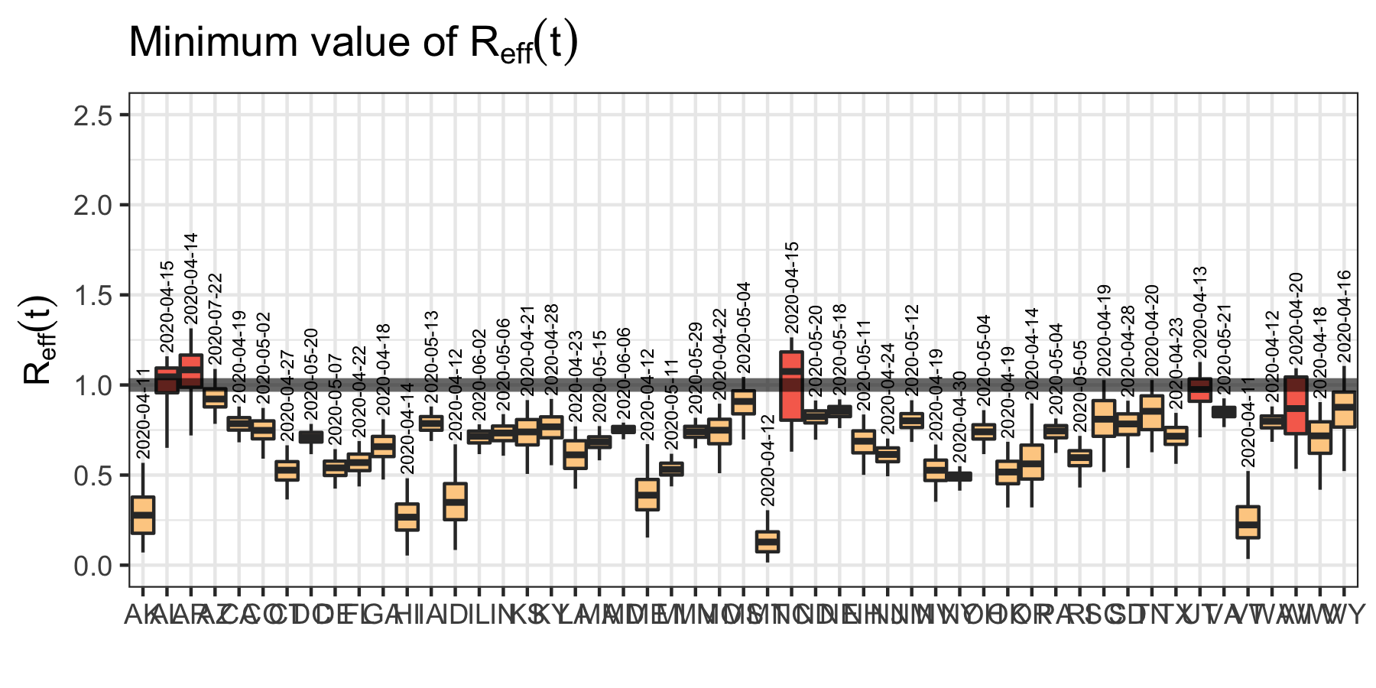

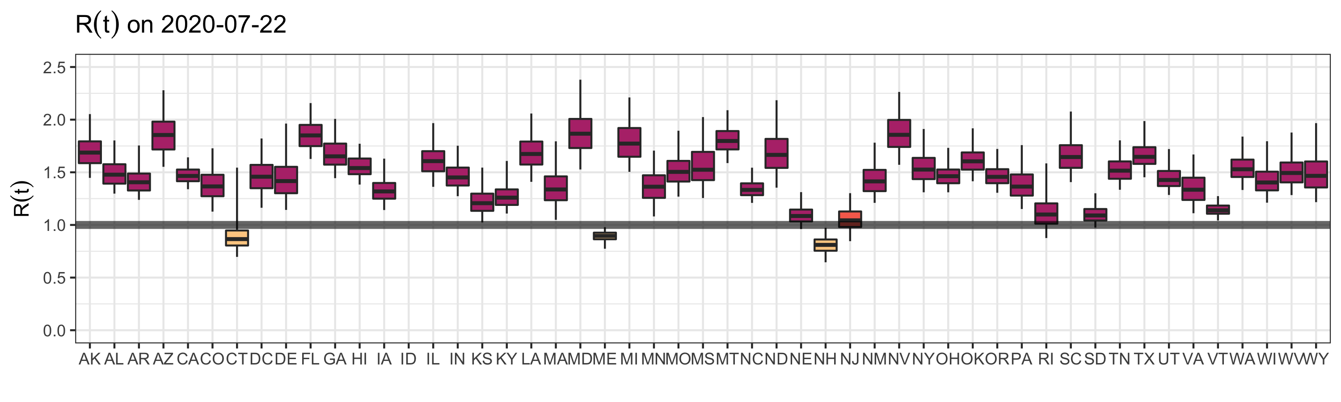

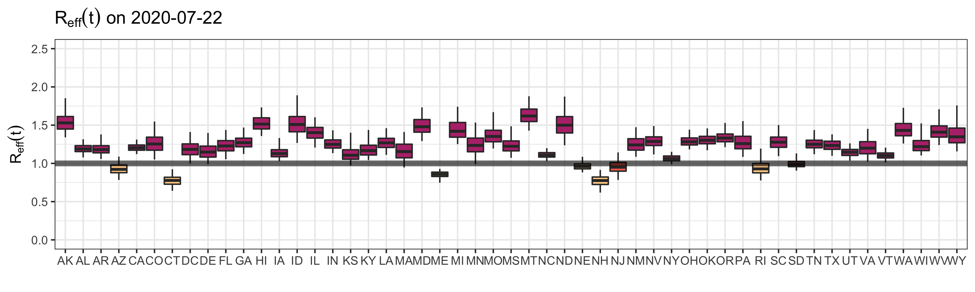

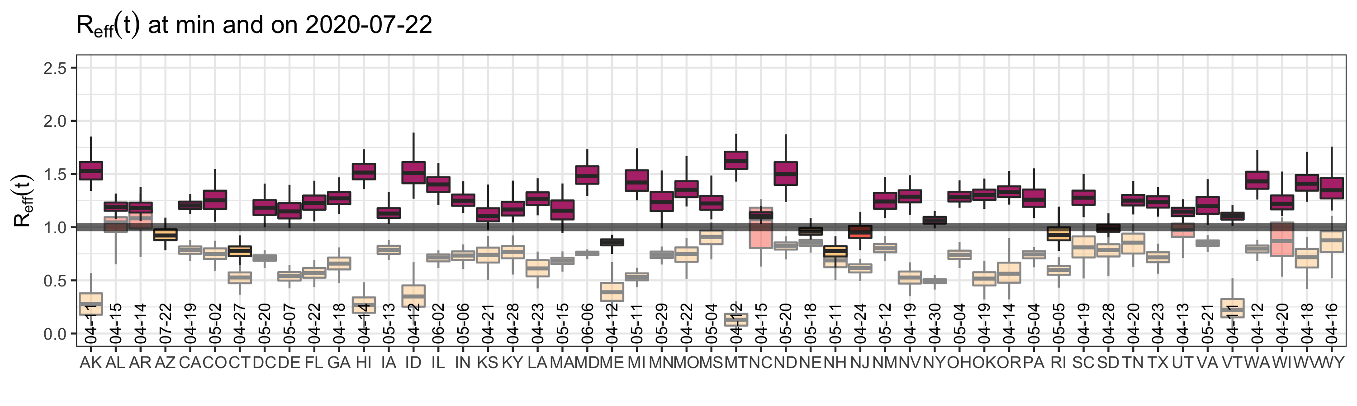

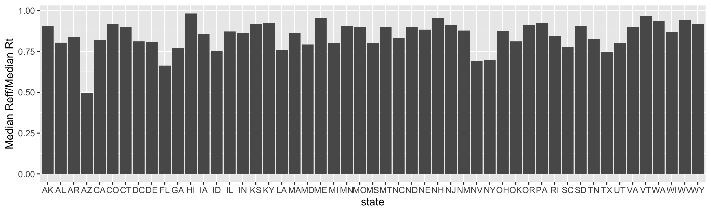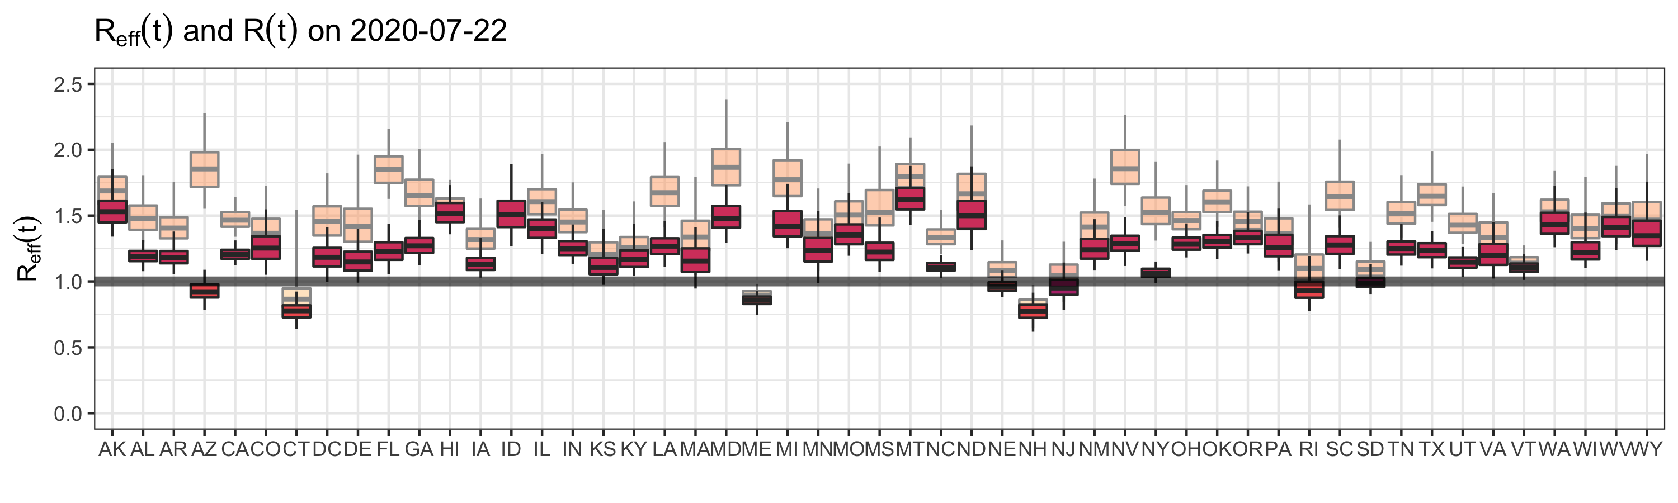

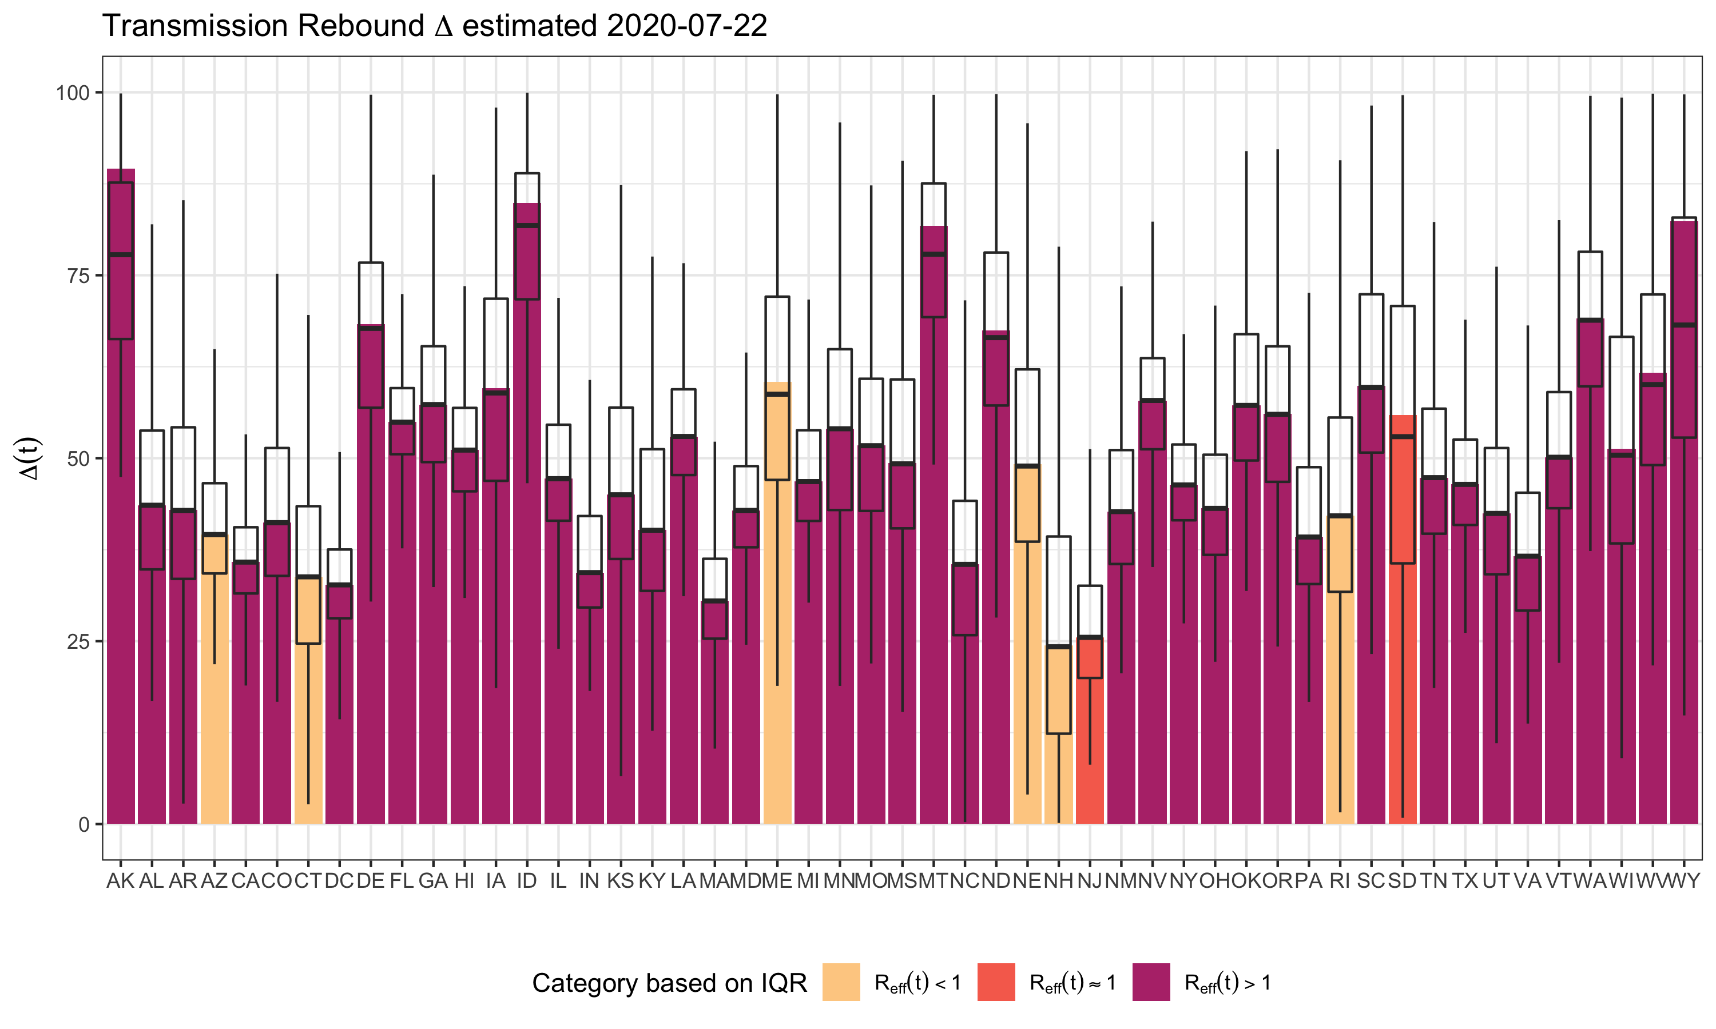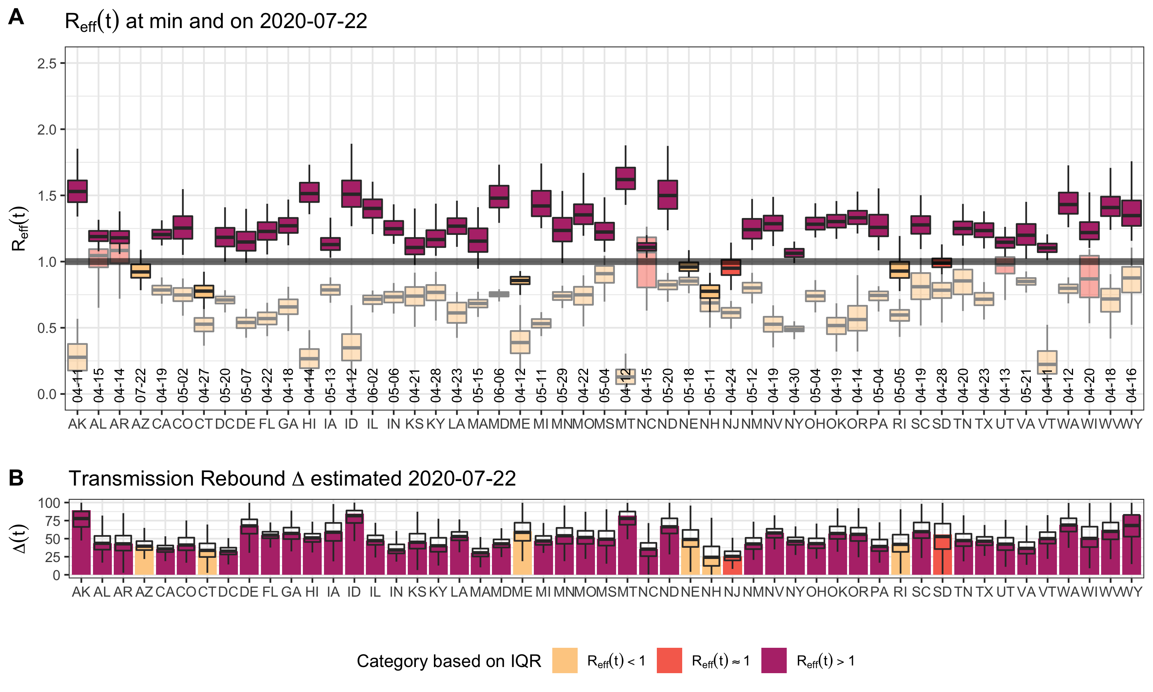

folder <- "../SEIR.reopen.state.2020.07.22"  
numDate <- as.numeric(as.Date("2020-07-22"))-as.numeric(as.Date(datezero))  
t <- numDate  
 scenparms <- data.frame()  
 for (statenow in statesarr) {   
 sampfile <- list.files(path=file.path(folder,statenow),  
 pattern="*OneTime.out",  
 full.names=TRUE)  
 parms <- read.delim(sampfile,as.is=TRUE,sep="\t")  
 names(parms)<-gsub("_1.1","",names(parms))  
 names(parms)<-gsub("GM_","",names(parms))  
 parms$state <- factor(statenow,levels=(sort(statesarr)))  
   
 ## Time dependent parameters, evaluated at last day  
 parms$ThetaFit <- (parms$ThetaMin -   
 (parms$ThetaMin - 1)*  
 exp(-((t-60)/parms$TauTheta)^parms$PwrTheta));  
 ## Reopening - increase contacts/day  
 parms$TimeReopen = 60+parms$TauTheta+parms$TauS;  
 parms$ReopenStart = (1 - 1/(1 + exp(4*(t - parms$TimeReopen))));  
 parms$ReopenStop = (1 - 1/(1 + exp(4*(t - (parms$TimeReopen+parms$TauR)))));  
 parms$ReopenPct = ((t - parms$TimeReopen)*(parms$rMax/parms$TauR)*(parms$ReopenStart-parms$ReopenStop)+parms$rMax*parms$ReopenStop);  
 ## Contacts/day  
 parms$c = parms$c0 * (parms$ThetaFit + (1 - parms$ThetaMin) * parms$ReopenPct);   
 ## Hygiene - reduce infection probability/infected contact  
 parms$HygieneFit <- parms$ThetaFit^parms$HygienePwr;  
 parms$beta <- parms$beta0 * parms$HygieneFit; # infection probability/infected contact  
 parms$Delta <- (parms$c*parms$beta -  
 parms$c0*parms$beta0*  
 parms$ThetaMin^(1+parms$HygienePwr))/  
 (parms$c0*parms$beta0 -  
 parms$c0*parms$beta0*  
 parms$ThetaMin^(1+parms$HygienePwr))  
 ## Time dependence of testing/contact tracting  
 parms$TestingTimeDep <- (1-1/(1+exp((t-parms$T50Testing)/parms$TauTesting)));   
 ## Contact tracing  
 parms$FTraced <- parms$FracTraced * parms$TestingTimeDep;  
 ## Testing  
 parms$lambda <- parms$TestingTimeDep * parms$lambda0;   
 parms$lambda_C <- parms$TestingTimeDep * parms$lambda0_C;   
 parms$rho_C <- parms$TestingTimeDep * parms$rho0_C;  
 parms$fracpos = parms$FTraced*parms$lambda_C/(parms$lambda_C + parms$rho_C)+(1-parms$FTraced)*parms$lambda/(parms$lambda+parms$rho); # fraction of infected that are tested and positive  
 ## Case fatality  
 parms$fracposmin <- parms$IFR / 0.9; # max 90% of cases fatal  
 parms$CFR <- ifelse(parms$fracpos > parms$fracposmin, parms$IFR/parms$fracpos, 0.9); # Adjust infected fatality to (tested) case fatality  
 parms$delta <- parms$rho * parms$CFR/(1-parms$CFR);  
 scenparms <- rbind(scenparms,parms)  
}  
scenparms<-scenparms[,!duplicated(names(scenparms))]  
scenparms.med<-aggregate(.~state,data=scenparms,median)

##   
## Call:  
## lm(formula = Refft ~ ., data = scenparms[, c("R0", "HygienePwr",   
## "ThetaMin", "rMax", "FracTraced", "FAsymp", "lambda", "rho",   
## "Refft")])  
##   
## Residuals:  
## Min 1Q Median 3Q Max   
## -0.79529 -0.08169 0.00929 0.09017 0.62280   
##   
## Coefficients:  
## Estimate Std. Error t value Pr(>|t|)   
## (Intercept) 0.620840 0.010708 57.977 < 2e-16 ***  
## R0 0.147459 0.001931 76.383 < 2e-16 ***  
## HygienePwr -0.388909 0.006514 -59.700 < 2e-16 ***  
## ThetaMin 0.110864 0.008121 13.651 < 2e-16 ***  
## rMax 0.440123 0.003699 118.978 < 2e-16 ***  
## FracTraced -0.902707 0.007874 -114.649 < 2e-16 ***  
## FAsymp -0.017208 0.005912 -2.911 0.00361 **   
## lambda -0.125860 0.028262 -4.453 8.49e-06 ***  
## rho 0.362210 0.025216 14.364 < 2e-16 ***  
## ---  
## Signif. codes: 0 '***' 0.001 '**' 0.01 '*' 0.05 '.' 0.1 ' ' 1  
##   
## Residual standard error: 0.1392 on 25491 degrees of freedom  
## Multiple R-squared: 0.572, Adjusted R-squared: 0.5718   
## F-statistic: 4258 on 8 and 25491 DF, p-value: < 2.2e-16

## Analysis of Variance Table  
##   
## Response: Refft  
## Df Sum Sq Mean Sq F value Pr(>F)   
## R0 1 72.40 72.404 3737.133 < 2.2e-16 ***  
## HygienePwr 1 57.91 57.913 2989.166 < 2.2e-16 ***  
## ThetaMin 1 100.31 100.308 5177.354 < 2.2e-16 ***  
## rMax 1 155.99 155.995 8051.610 < 2.2e-16 ***  
## FracTraced 1 268.03 268.026 13834.053 < 2.2e-16 ***  
## FAsymp 1 0.41 0.414 21.344 3.857e-06 ***  
## lambda 1 0.91 0.907 46.813 7.987e-12 ***  
## rho 1 4.00 3.998 206.330 < 2.2e-16 ***  
## Residuals 25491 493.87 0.019   
## ---  
## Signif. codes: 0 '***' 0.001 '**' 0.01 '*' 0.05 '.' 0.1 ' ' 1

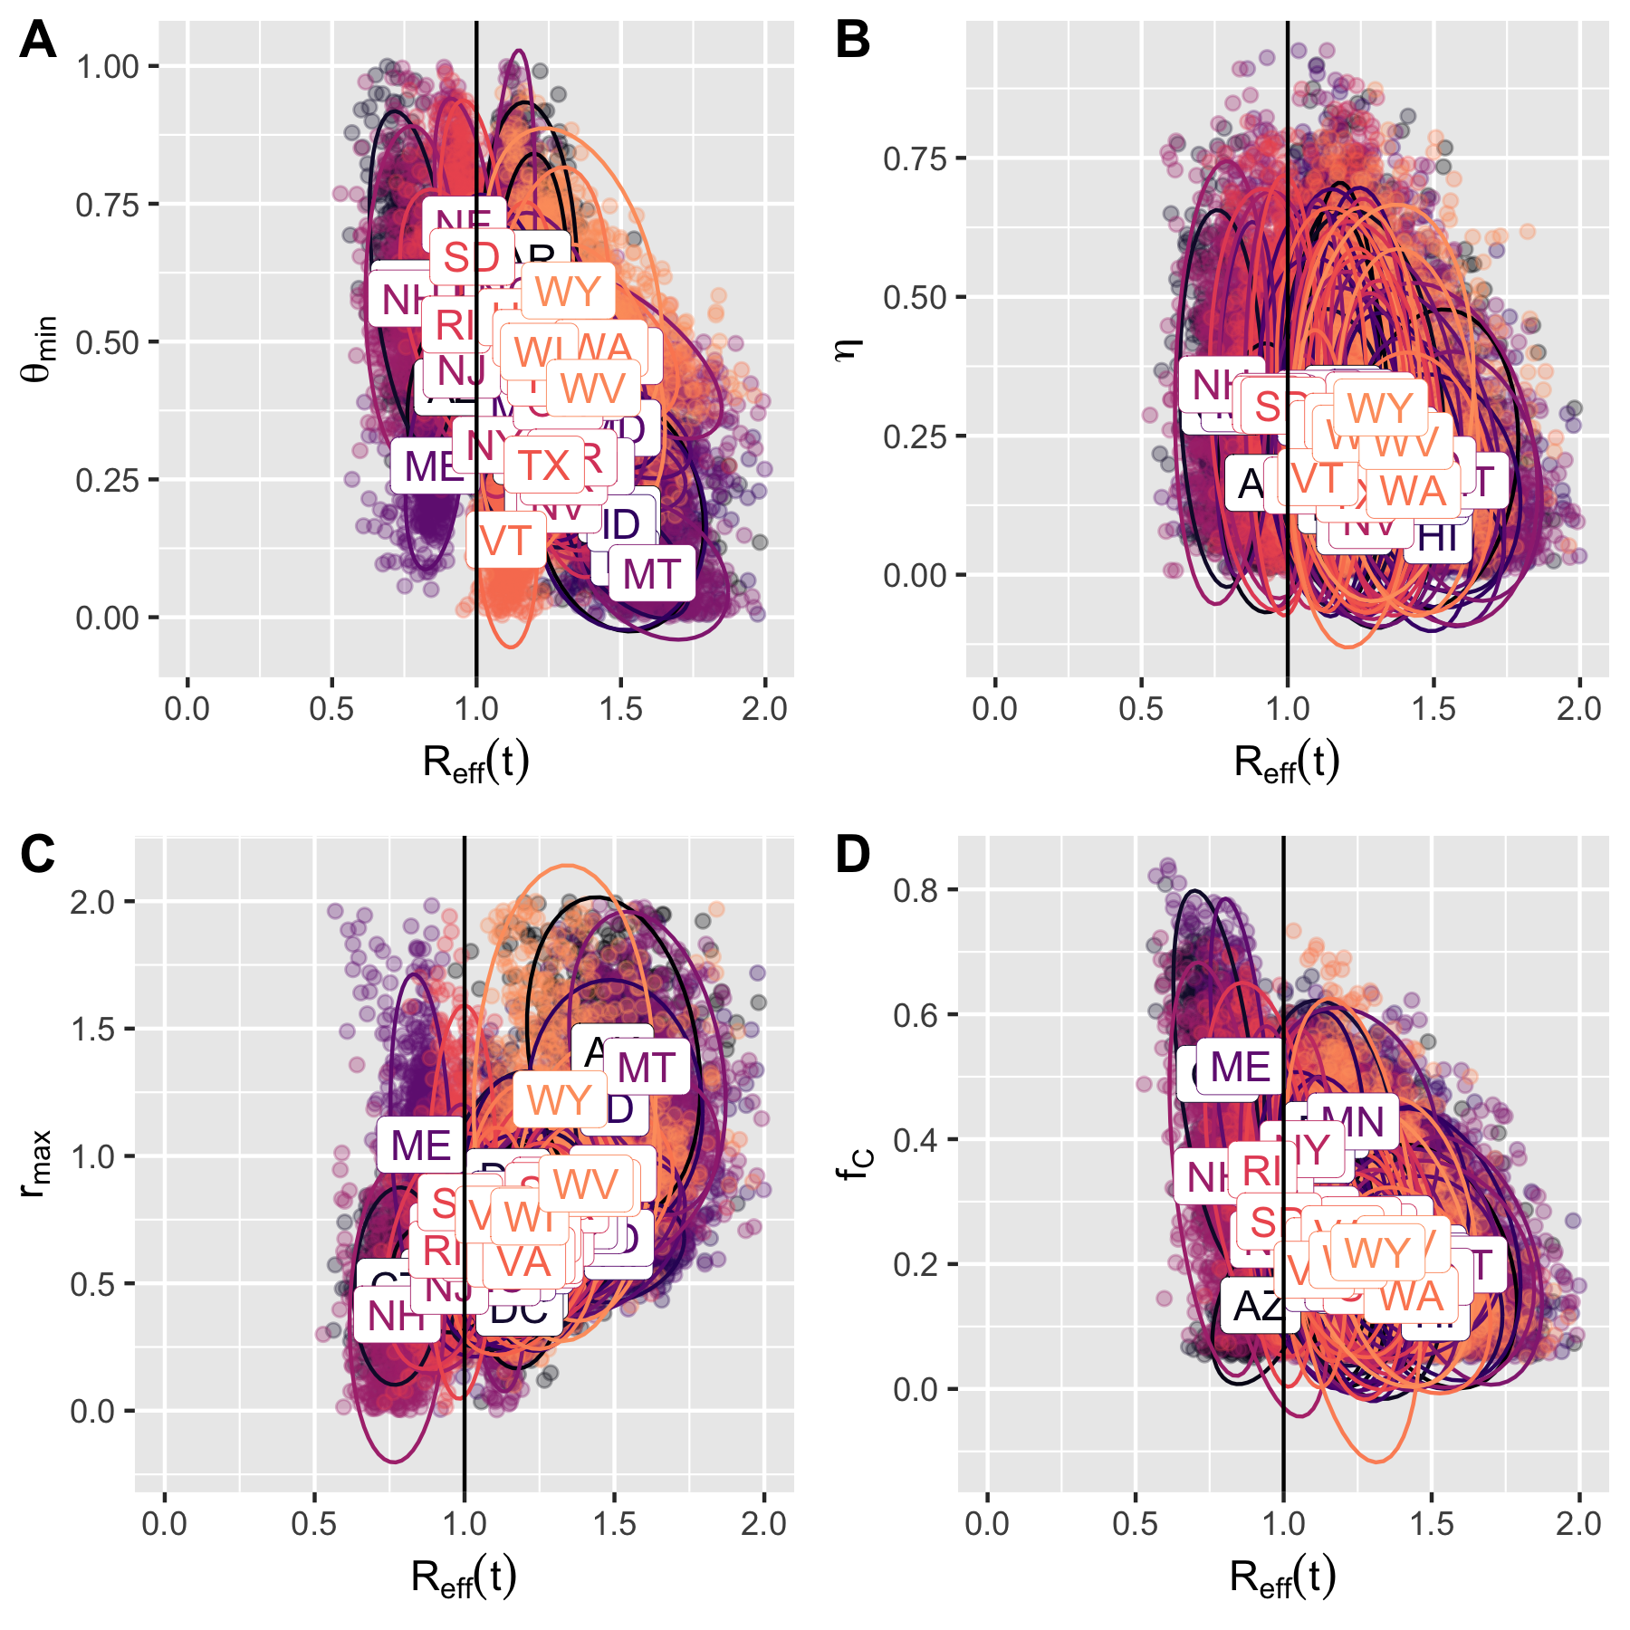

##   
## Call:  
## lm(formula = Rt ~ ., data = allparms[, c("R0", "HygienePwr",   
## "ThetaMin", "rMax", "FracTraced", "FAsymp", "lambda", "rho",   
## "Rt")])  
##   
## Residuals:  
## Min 1Q Median 3Q Max   
## -0.94355 -0.07643 0.00075 0.07636 1.13525   
##   
## Coefficients:  
## Estimate Std. Error t value Pr(>|t|)   
## (Intercept) 0.122083 0.011108 10.99 <2e-16 ***  
## R0 0.314068 0.002002 156.84 <2e-16 ***  
## HygienePwr -0.840976 0.006757 -124.46 <2e-16 ***  
## ThetaMin 0.621163 0.008424 73.74 <2e-16 ***  
## rMax 0.693221 0.003837 180.66 <2e-16 ***  
## FracTraced -1.621546 0.008167 -198.54 <2e-16 ***  
## FAsymp 0.369897 0.006132 60.32 <2e-16 ***  
## lambda -3.248934 0.029315 -110.83 <2e-16 ***  
## rho 0.844522 0.026156 32.29 <2e-16 ***  
## ---  
## Signif. codes: 0 '***' 0.001 '**' 0.01 '*' 0.05 '.' 0.1 ' ' 1  
##   
## Residual standard error: 0.1444 on 25491 degrees of freedom  
## Multiple R-squared: 0.7736, Adjusted R-squared: 0.7735   
## F-statistic: 1.089e+04 on 8 and 25491 DF, p-value: < 2.2e-16

## Analysis of Variance Table  
##   
## Response: Rt  
## Df Sum Sq Mean Sq F value Pr(>F)   
## R0 1 313.19 313.19 15024.0 < 2.2e-16 ***  
## HygienePwr 1 183.42 183.42 8799.0 < 2.2e-16 ***  
## ThetaMin 1 137.06 137.06 6574.8 < 2.2e-16 ***  
## rMax 1 247.37 247.37 11866.6 < 2.2e-16 ***  
## FracTraced 1 590.89 590.89 28345.8 < 2.2e-16 ***  
## FAsymp 1 34.34 34.34 1647.3 < 2.2e-16 ***  
## lambda 1 287.87 287.87 13809.6 < 2.2e-16 ***  
## rho 1 21.73 21.73 1042.5 < 2.2e-16 ***  
## Residuals 25491 531.38 0.02   
## ---  
## Signif. codes: 0 '***' 0.001 '**' 0.01 '*' 0.05 '.' 0.1 ' ' 1

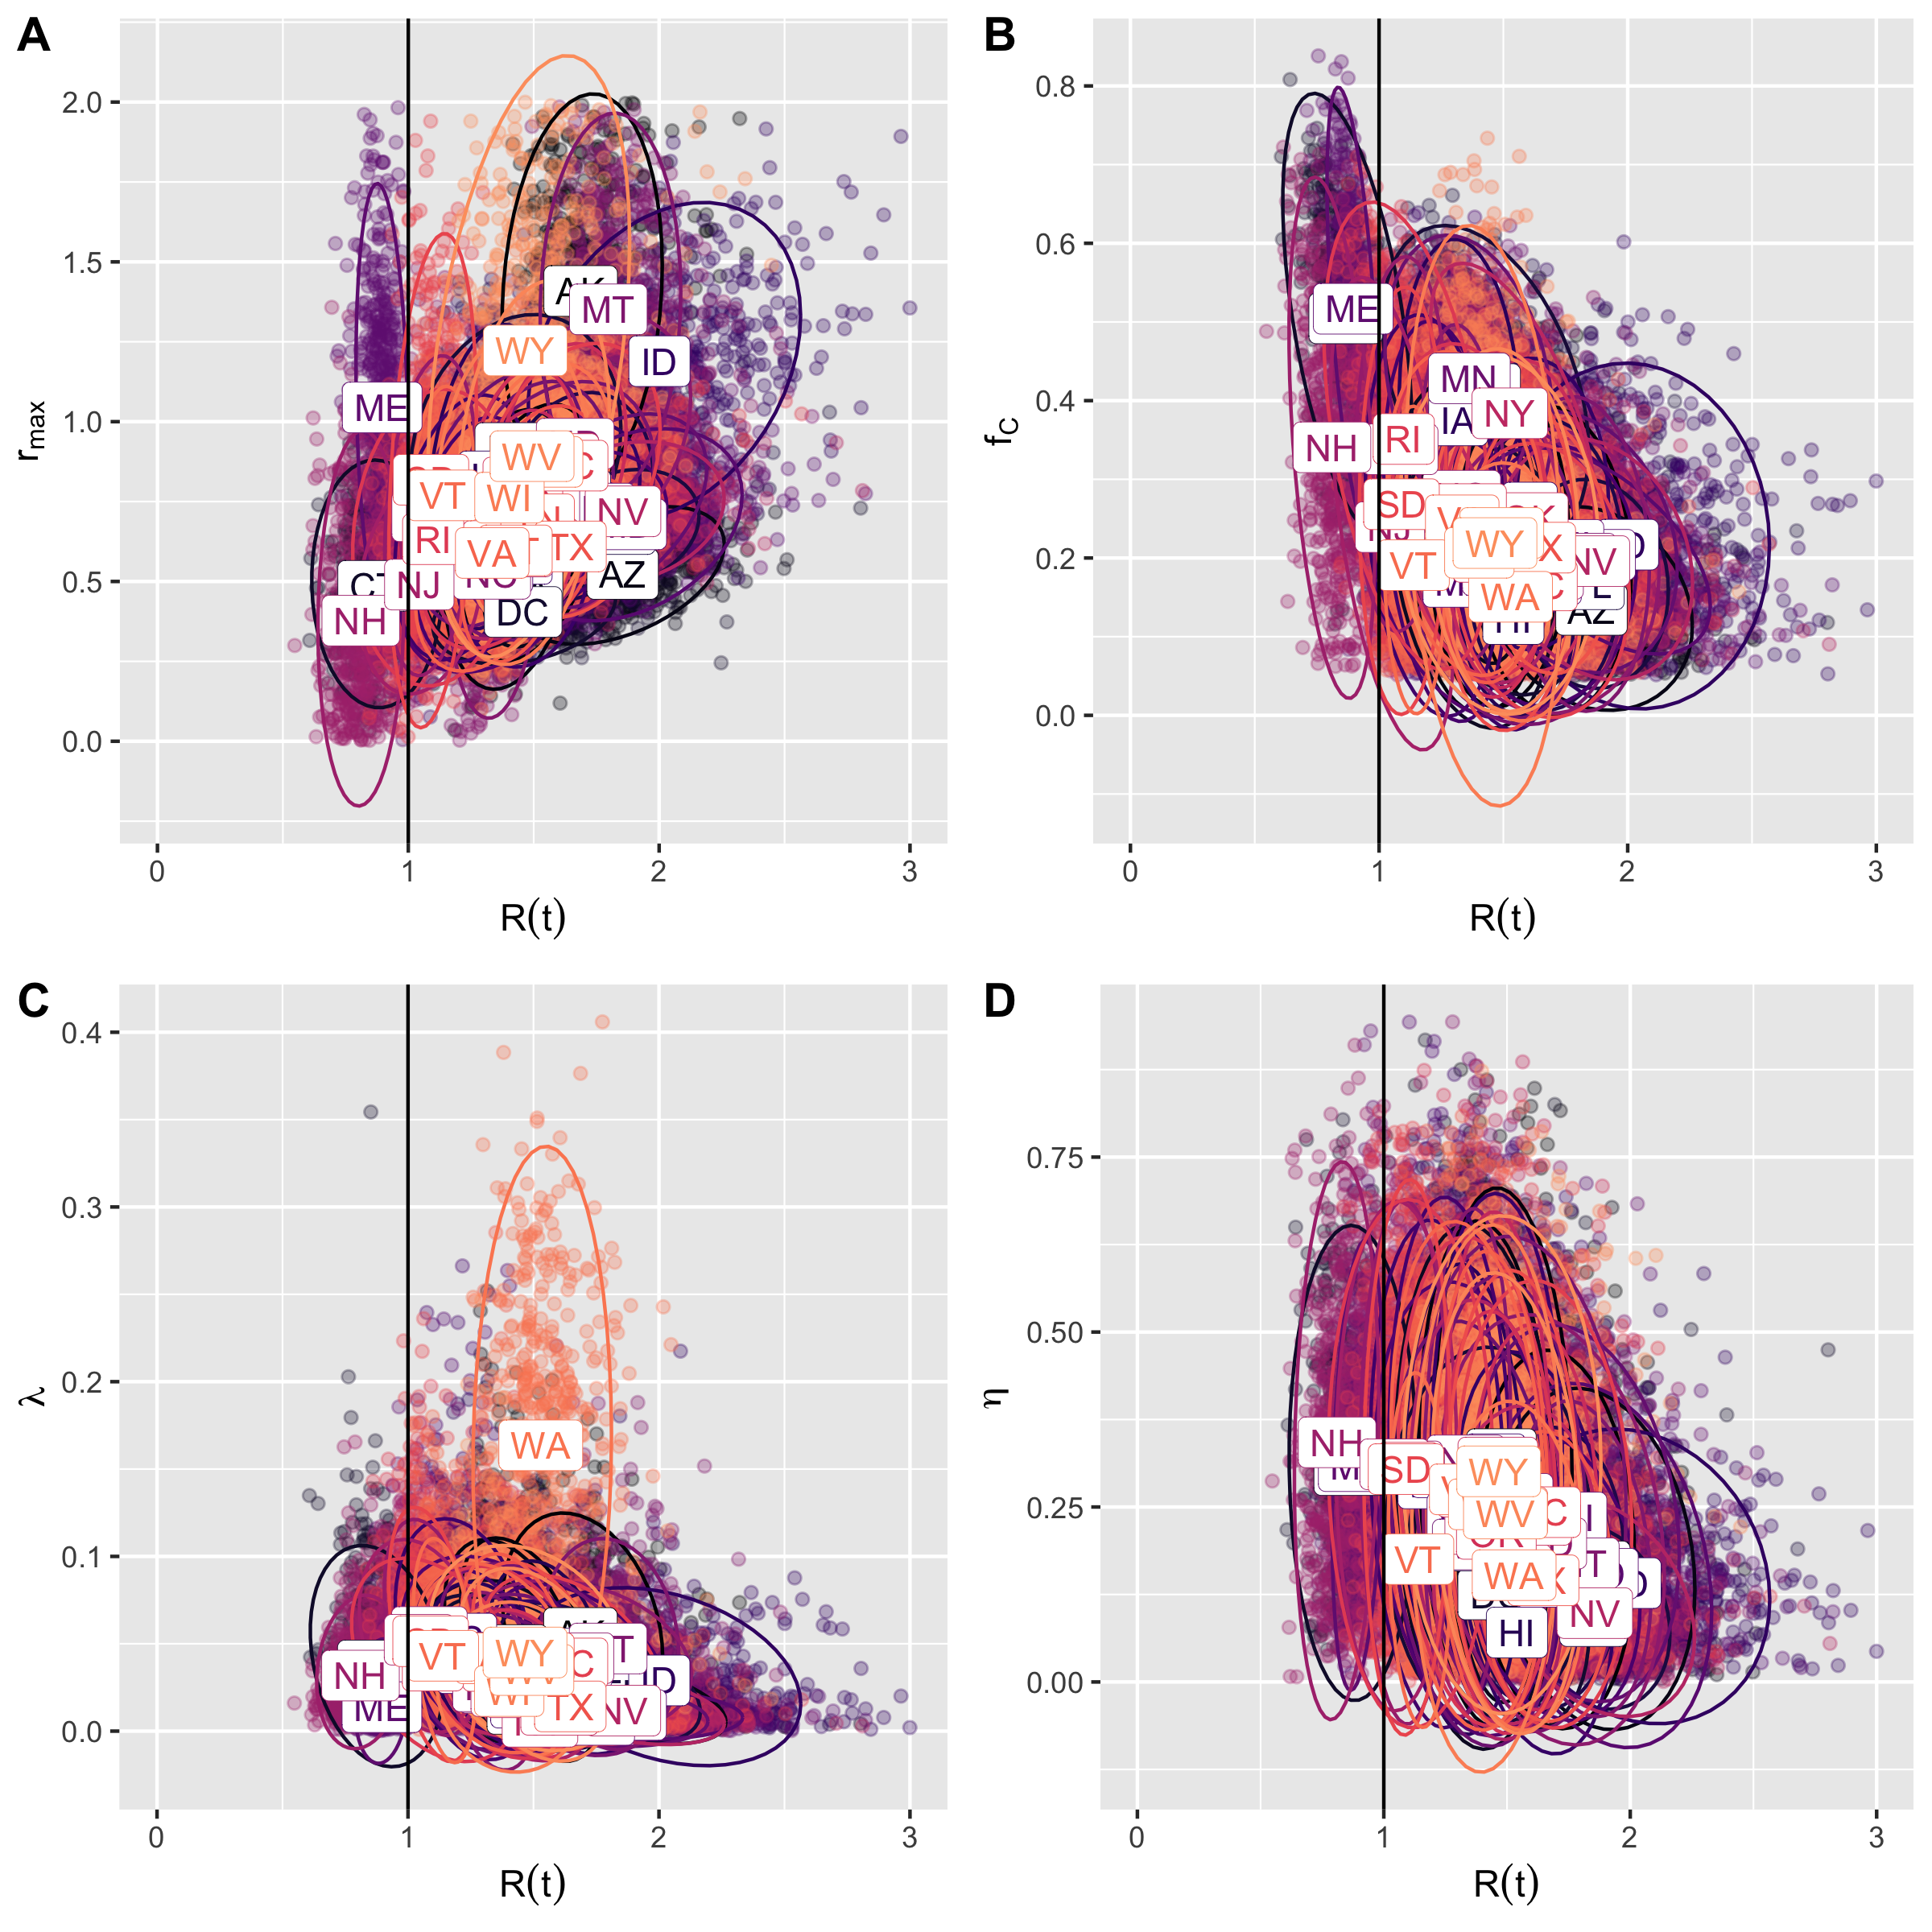

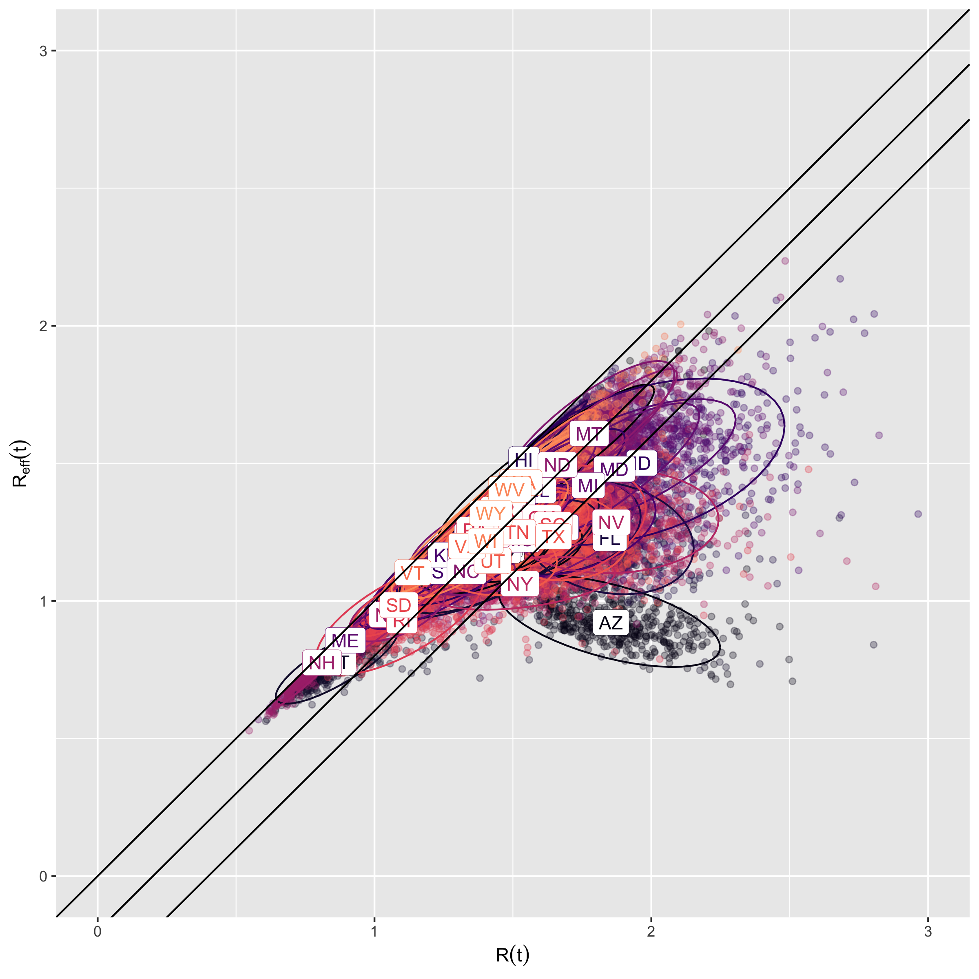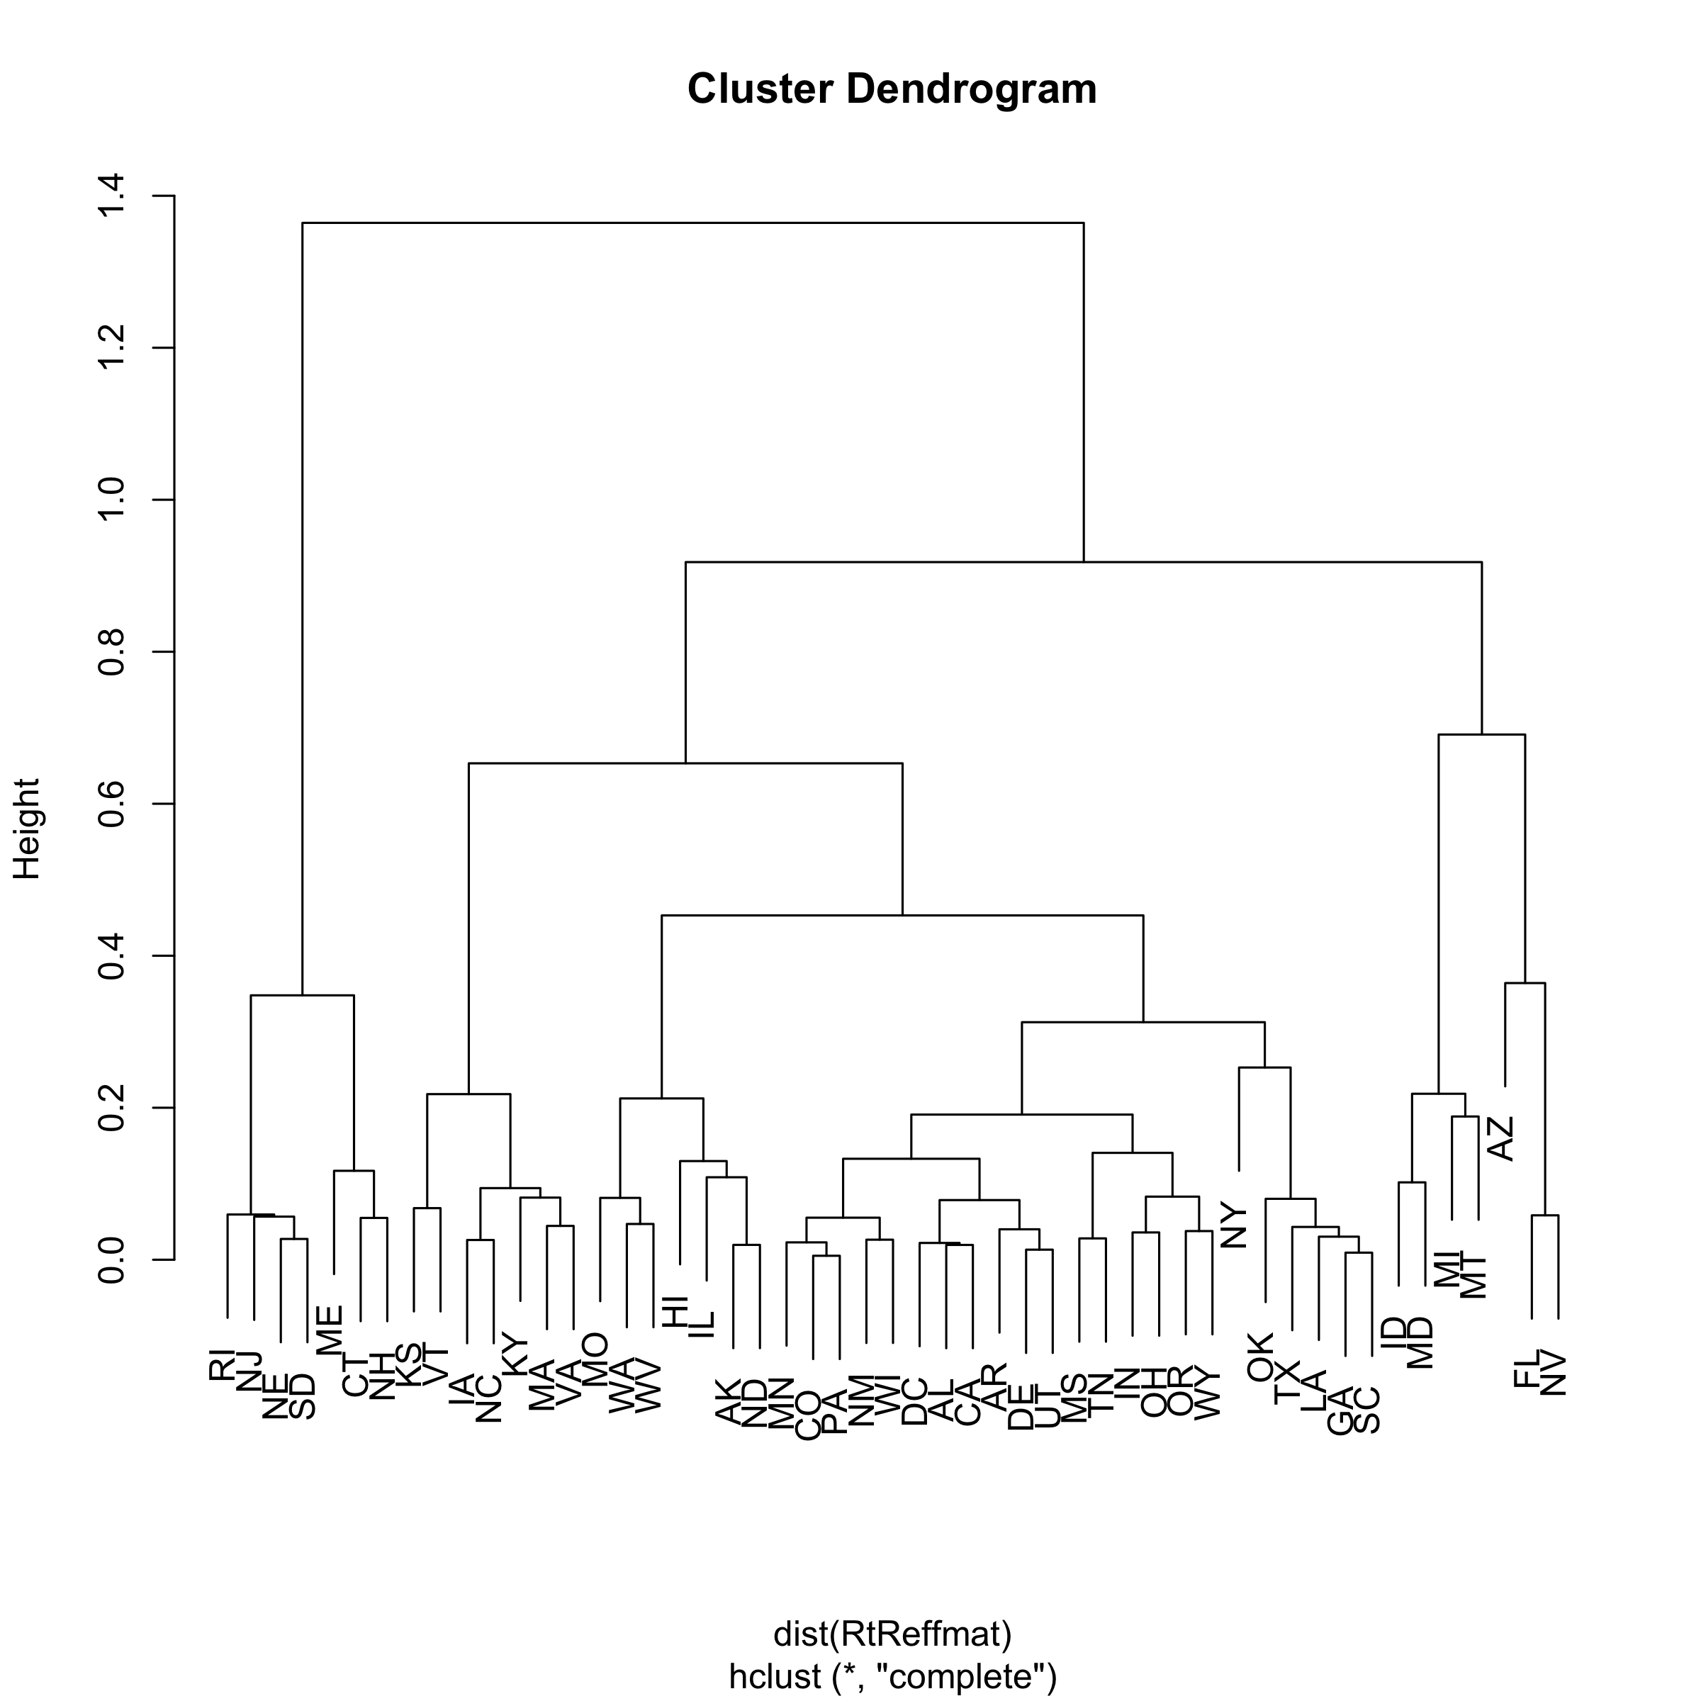

scenparms<-scenparms[,!duplicated(names(scenparms))]  
scenparms$Category <- fips_table[as.character(scenparms$state),"RtCategory"]  
  
# checkRefft0 <- scenparms$S*scenparms$c*scenparms$beta*(1 - scenparms$FTraced)*(  
# (1-scenparms$FAsymp)/(scenparms$rho+scenparms$lambda)+  
# scenparms$FAsymp/scenparms$rho  
# )  
# print(quantile(checkRefft0/scenparms$Refft,prob=c(0,0.01,0.05,0.5,0.95,0.99,1)))  
  
muCcritfunc<-function(scenparms) {  
 muCcrit <- (1 - 1/(scenparms$S*scenparms$c*scenparms$beta*  
 ((1-scenparms$FAsymp)/(scenparms$rho+scenparms$lambda)+  
 scenparms$FAsymp/scenparms$rho)))/scenparms$FTraced  
 # checkRefft <- scenparms$S*scenparms$c*scenparms$beta*(1 - muCcrit*scenparms$FTraced)*(  
 # (1-scenparms$FAsymp)/(scenparms$rho+scenparms$lambda)+  
 # scenparms$FAsymp/scenparms$rho  
 # )  
 # print(quantile(checkRefft,prob=c(0,0.01,0.05,0.5,0.95,0.99,1)))  
 muCcrit[scenparms$Refft<=1]<-1  
 muCcrit[muCcrit<1]<-1  
 return(muCcrit)  
}  
  
mulambdacritfunc<-function(scenparms) {  
 mulambdacrit <- (scenparms$rho/scenparms$lambda)*  
 (scenparms$S*scenparms$c*scenparms$beta*(1-scenparms$FTraced) - scenparms$rho)/  
 (scenparms$rho - scenparms$FAsymp*scenparms$S*scenparms$c*scenparms$beta*(1-scenparms$FTraced))  
 # checkRefft <- scenparms$S*scenparms$c*scenparms$beta*(1 - scenparms$FTraced)*(  
 # (1-scenparms$FAsymp)/(scenparms$rho+mulambdacrit*scenparms$lambda)+  
 # scenparms$FAsymp/scenparms$rho  
 # )  
 # print(quantile(checkRefft,prob=c(0,0.01,0.05,0.5,0.95,0.99,1)))  
 mulambdacrit[scenparms$Refft<=1]<-1  
 mulambdacrit[mulambdacrit<1]<-1  
 return(mulambdacrit)  
}  
  
mubothcritfunc<-function(scenparms) {  
 tmp_b <- (scenparms$rho*scenparms$lambda+  
 scenparms$S*scenparms$c*scenparms$beta*(  
 scenparms$FTraced*scenparms$rho - scenparms$FAsymp*scenparms$lambda  
 ))/  
 (scenparms$S*scenparms$c*scenparms$beta*scenparms$lambda*scenparms$FTraced*scenparms$FAsymp)  
 tmp_c <- scenparms$rho*(scenparms$rho - scenparms$S*scenparms$c*scenparms$beta)/  
 (scenparms$S*scenparms$c*scenparms$beta*scenparms$lambda*scenparms$FTraced*scenparms$FAsymp)  
 mubothcrit <- (-tmp_b + sqrt(tmp_b^2 - 4*tmp_c))/2  
 # checkRefft <- scenparms$S*scenparms$c*scenparms$beta*(1 - mubothcrit*scenparms$FTraced)*(  
 # (1-scenparms$FAsymp)/(scenparms$rho+mubothcrit*scenparms$lambda)+  
 # scenparms$FAsymp/scenparms$rho  
 # )  
 # print(quantile(checkRefft,prob=c(0,0.01,0.05,0.5,0.95,0.99,1)))  
 mubothcrit[scenparms$Refft<=1]<-1  
 mubothcrit[mubothcrit<1]<-1  
 return(mubothcrit)  
}  
  
tmpdf <- cbind(scenparms[,c("state","Rt","Refft","Category")],  
 data.table(muCcrit=muCcritfunc(scenparms),  
 mulambdacrit=mulambdacritfunc(scenparms),  
 mubothcrit=mubothcritfunc(scenparms)))  
  
tmpdf.quantiles<-aggregate(.~state,data=tmpdf[,c("state","muCcrit","mulambdacrit","mubothcrit")],  
 quantile,prob=c(0.025,0.5,0.975))  
fwrite(as.data.table(tmpdf.quantiles),"TestTraceCritValues.csv")  
  
  
tmpdf.df<-melt(as.data.table(tmpdf),id.vars=c("state","Category","Rt","Refft"),  
 measure.vars = c("muCcrit","mulambdacrit","mubothcrit"))  
tmpdf.df$variable<-factor(tmpdf.df$variable,levels=c(  
 "mulambdacrit","muCcrit","mubothcrit"  
))  
dflabs<-c("Increase Testing","Increase Tracing","Increase Testing and Tracing")  
names(dflabs)<-c("mulambdacrit","muCcrit","mubothcrit")  
  
ptesttrace<-ggplot(data=tmpdf.df,  
 aes(x=state,  
 y=value,fill=Category  
 )) +   
 geom_boxplot(outlier.shape = NA,position="dodge")+  
 scale_fill_viridis_d(begin=0.9,end=0.5,option="magma",  
 labels=list(bquote(R[eff](t)<1),  
 bquote(R[eff](t)%~~%1),  
 bquote(R[eff](t)>1)))+  
 #ylab(bquote(paste("Percent increase in both testing and tracing for ",R[eff](t)<1)))+  
 ylab(bquote(paste("Fold increase in testing and/or tracing for ",R[eff](t)<1)))+  
 scale_y_continuous( labels = function(x) paste0(x, "X"),breaks=1:6)+  
 labs(fill="",color="",shape="")+  
 theme_bw()+theme(legend.position="bottom")+  
 geom_hline(yintercept=0)+  
 coord_cartesian(ylim=c(1,6))+  
 facet_wrap(~variable,ncol=1,  
 labeller = labeller(variable=dflabs))  
print(ptesttrace)

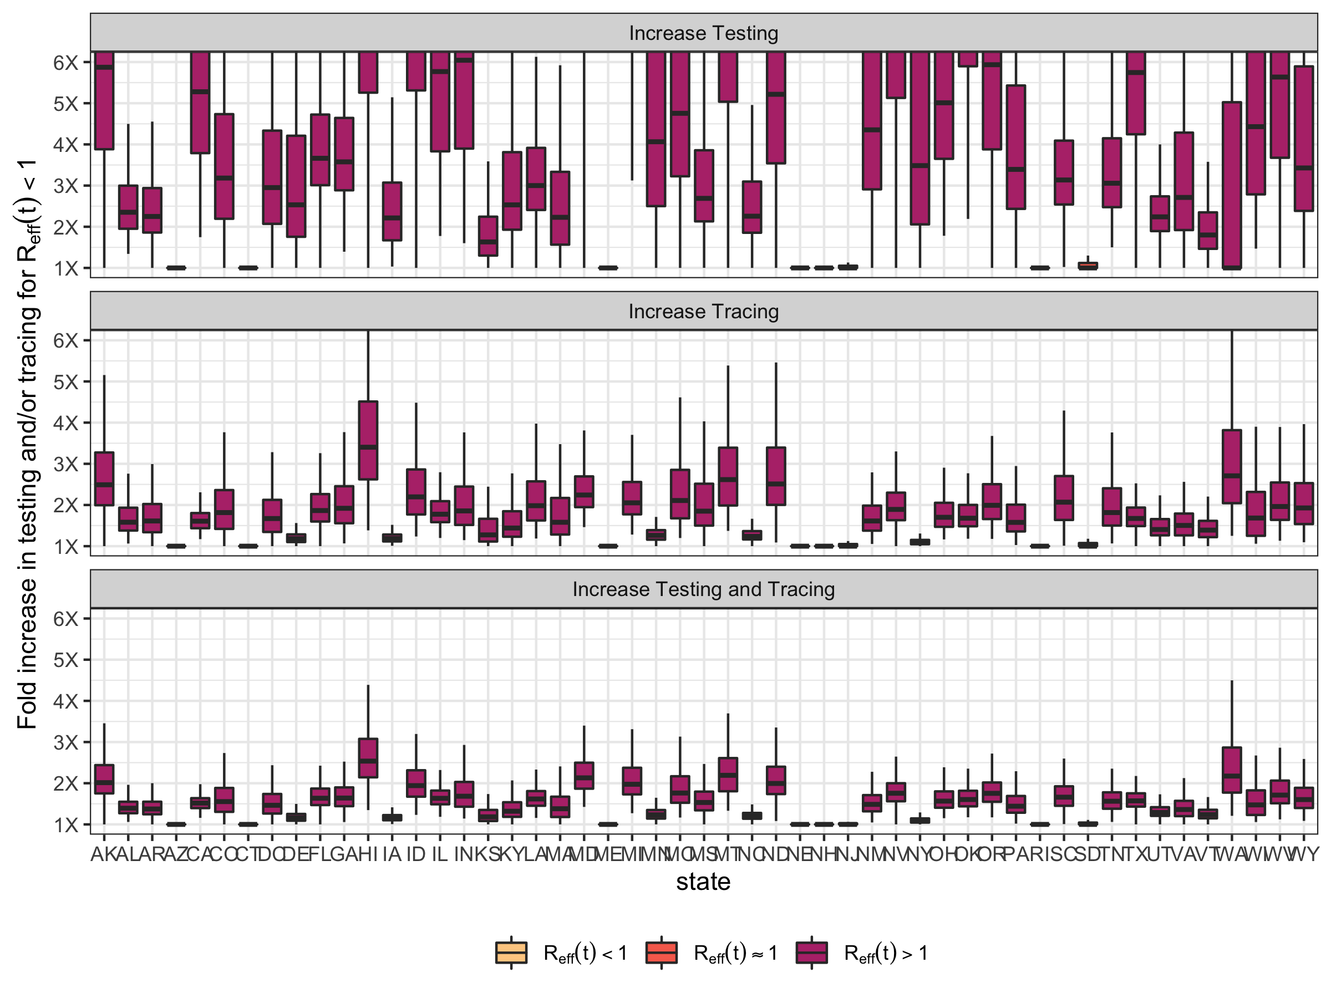

ggsave("Fig4A_TestingTracing.2020.07.22.pdf",plot=ptesttrace,height=4,width=6,scale=1.75)  
ggsave("Fig4A_TestingTracing.2020.07.22.jpeg",plot=ptesttrace,height=4,width=6,scale=1.75)

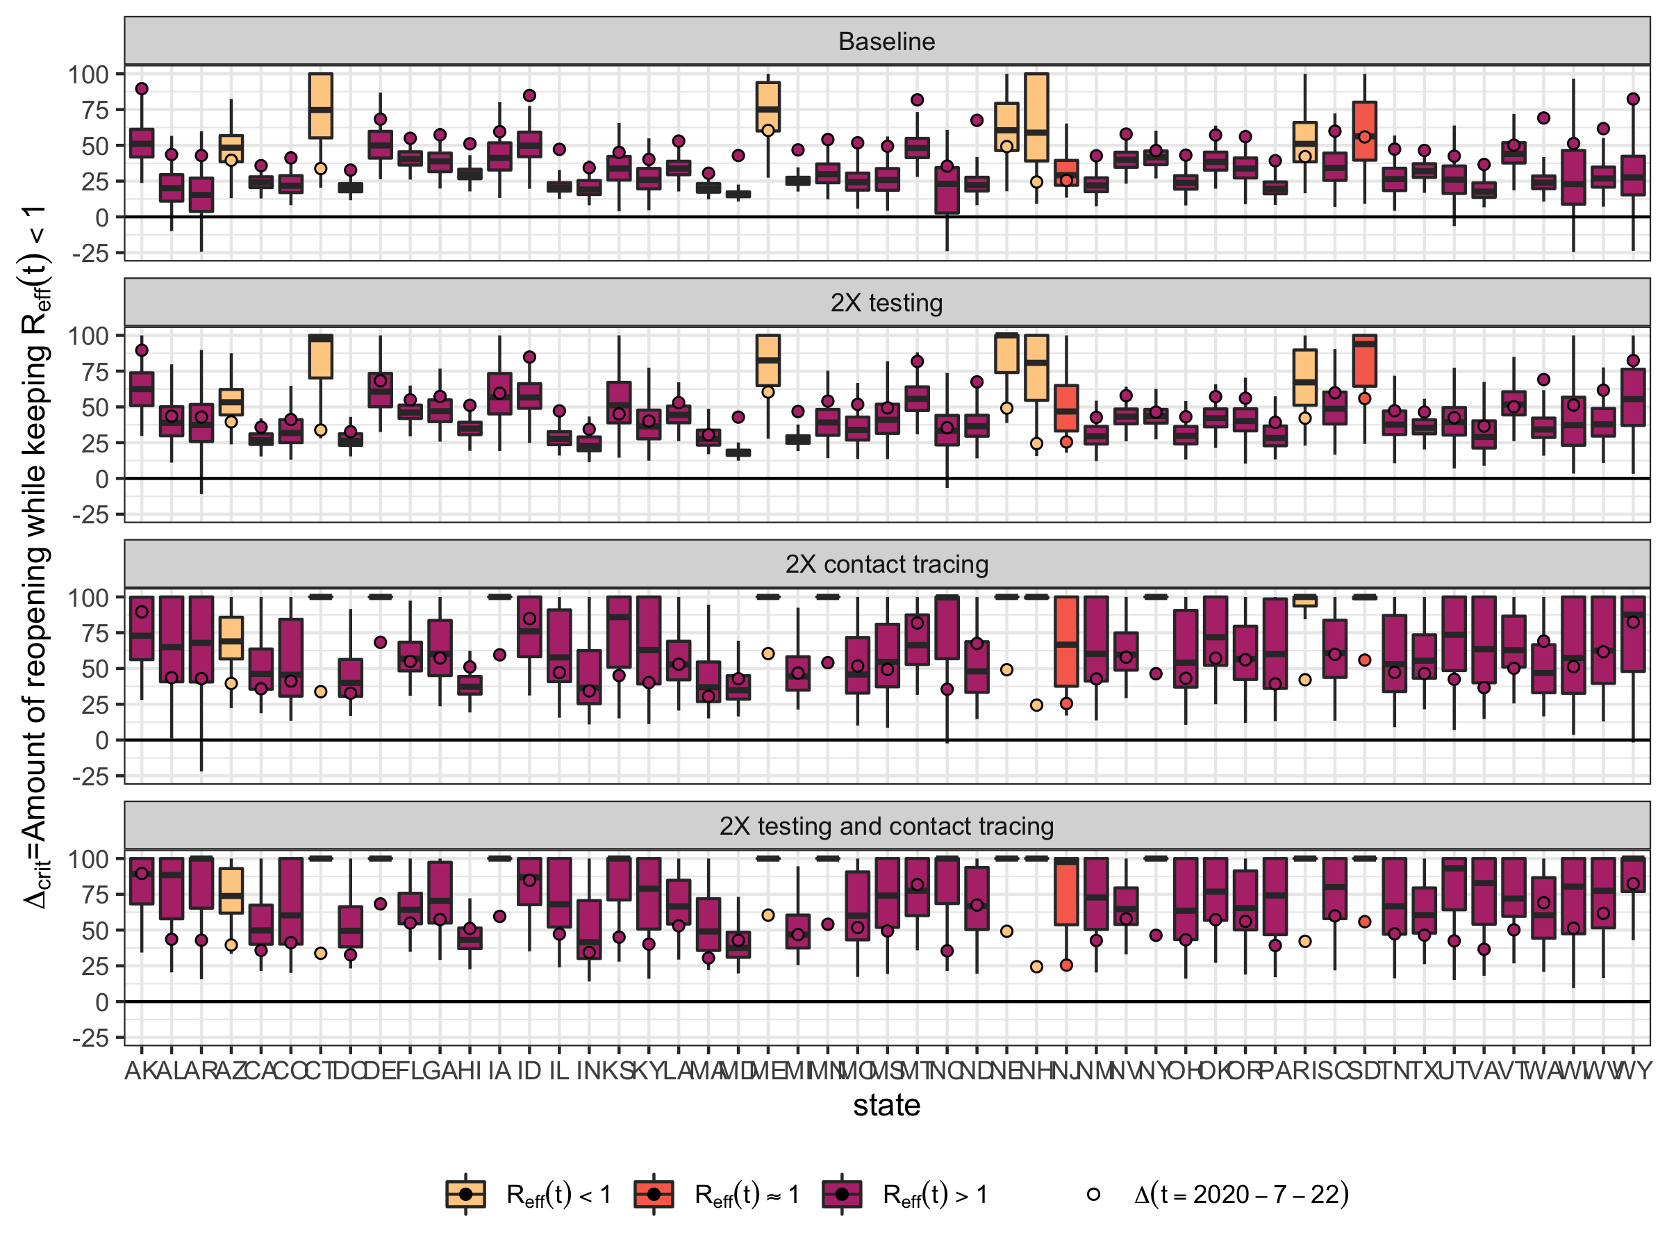

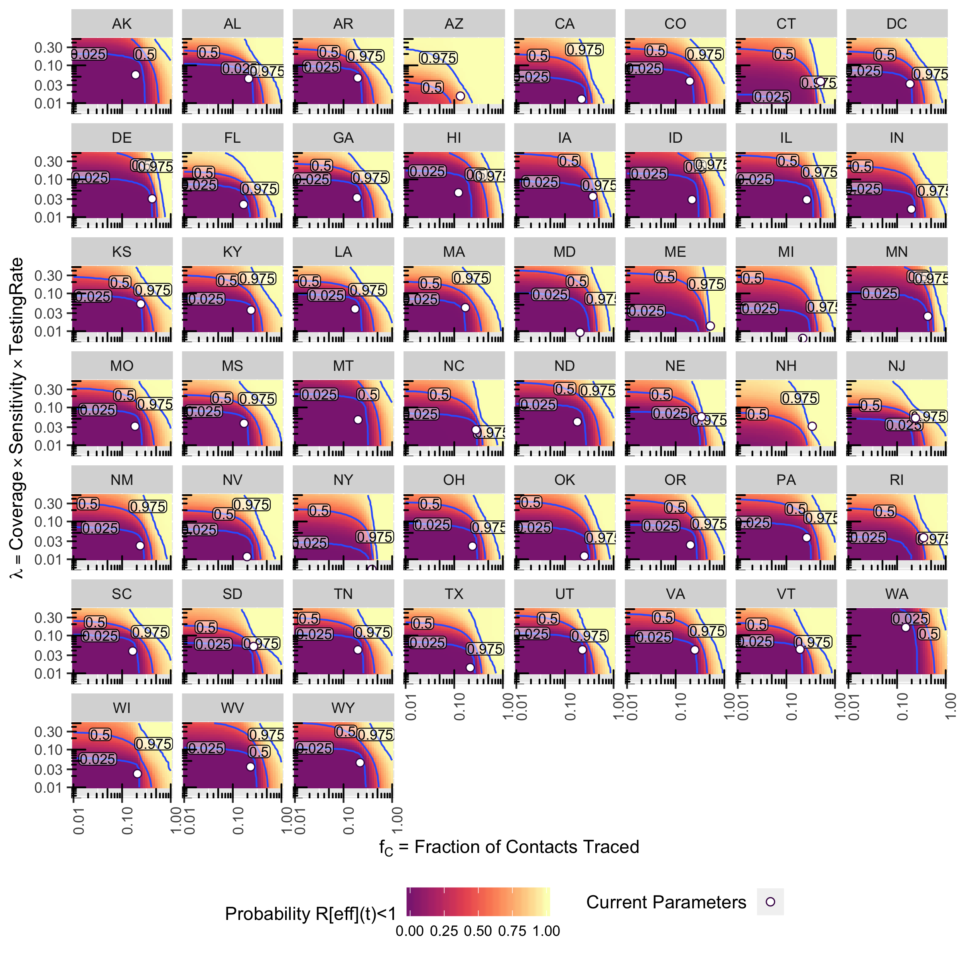

Critical testing/tracing using R(t) and assuming complete reopening (using c0 and beta0 instead of c and beta).

scenparms<-scenparms[,!duplicated(names(scenparms))]  
scenparms$Category <- fips_table[as.character(scenparms$state),"RtCategory"]  
  
# checkRefft0 <- scenparms$S*scenparms$c*scenparms$beta*(1 - scenparms$FTraced)*(  
# (1-scenparms$FAsymp)/(scenparms$rho+scenparms$lambda)+  
# scenparms$FAsymp/scenparms$rho  
# )  
# print(quantile(checkRefft0/scenparms$Refft,prob=c(0,0.01,0.05,0.5,0.95,0.99,1)))  
  
muCcritreopenfunc<-function(scenparms) {  
 muCcrit <- (1 - 1/(scenparms$c0*scenparms$beta0*  
 ((1-scenparms$FAsymp)/(scenparms$rho+scenparms$lambda)+  
 scenparms$FAsymp/scenparms$rho)))/scenparms$FTraced  
 # checkRefft <- scenparms$S*scenparms$c*scenparms$beta*(1 - muCcrit*scenparms$FTraced)*(  
 # (1-scenparms$FAsymp)/(scenparms$rho+scenparms$lambda)+  
 # scenparms$FAsymp/scenparms$rho  
 # )  
 # print(quantile(checkRefft,prob=c(0,0.01,0.05,0.5,0.95,0.99,1)))  
 muCcrit[muCcrit<1]<-1  
 return(muCcrit)  
}  
  
mulambdacritreopenfunc<-function(scenparms) {  
 mulambdacrit <- (scenparms$rho/scenparms$lambda)*  
 (scenparms$c0*scenparms$beta0*(1-scenparms$FTraced) - scenparms$rho)/  
 (scenparms$rho - scenparms$FAsymp*scenparms$S*scenparms$c*scenparms$beta*(1-scenparms$FTraced))  
 # checkRefft <- scenparms$S*scenparms$c*scenparms$beta*(1 - scenparms$FTraced)*(  
 # (1-scenparms$FAsymp)/(scenparms$rho+mulambdacrit*scenparms$lambda)+  
 # scenparms$FAsymp/scenparms$rho  
 # )  
 # print(quantile(checkRefft,prob=c(0,0.01,0.05,0.5,0.95,0.99,1)))  
 mulambdacrit[mulambdacrit<1]<-1  
 return(mulambdacrit)  
}  
  
mubothcritreopenfunc<-function(scenparms) {  
 tmp_b <- (scenparms$rho*scenparms$lambda+  
 scenparms$c0*scenparms$beta0*(  
 scenparms$FTraced*scenparms$rho - scenparms$FAsymp*scenparms$lambda  
 ))/  
 (scenparms$c0*scenparms$beta0*scenparms$lambda*scenparms$FTraced*scenparms$FAsymp)  
 tmp_c <- scenparms$rho*(scenparms$rho - scenparms$c0*scenparms$beta0)/  
 (scenparms$c0*scenparms$beta0*scenparms$lambda*scenparms$FTraced*scenparms$FAsymp)  
 mubothcrit <- (-tmp_b + sqrt(tmp_b^2 - 4*tmp_c))/2  
 # checkRefft <- scenparms$S*scenparms$c*scenparms$beta*(1 - mubothcrit*scenparms$FTraced)*(  
 # (1-scenparms$FAsymp)/(scenparms$rho+mubothcrit*scenparms$lambda)+  
 # scenparms$FAsymp/scenparms$rho  
 # )  
 # print(quantile(checkRefft,prob=c(0,0.01,0.05,0.5,0.95,0.99,1)))  
 mubothcrit[mubothcrit<1]<-1  
 return(mubothcrit)  
}  
  
tmpdf <- cbind(scenparms[,c("state","Rt","Refft","Category")],  
 data.table(muCcrit=muCcritreopenfunc(scenparms),  
 mulambdacrit=mulambdacritreopenfunc(scenparms),  
 mubothcrit=mubothcritreopenfunc(scenparms)))  
  
tmpdf.quantiles<-aggregate(.~state,data=tmpdf[,c("state","muCcrit","mulambdacrit","mubothcrit")],  
 quantile,prob=c(0.025,0.5,0.975))  
  
  
tmpdf.df<-melt(as.data.table(tmpdf),id.vars=c("state","Category","Rt","Refft"),  
 measure.vars = c("muCcrit","mulambdacrit","mubothcrit"))  
tmpdf.df$variable<-factor(tmpdf.df$variable,levels=c(  
 "mulambdacrit","muCcrit","mubothcrit"  
))  
dflabs<-c("Increase Testing","Increase Tracing","Increase Testing and Tracing")  
names(dflabs)<-c("mulambdacrit","muCcrit","mubothcrit")  
  
ptesttracereopen<-ggplot(data=tmpdf.df,  
 aes(x=state,  
 y=value,fill=Category  
 )) +   
 geom_boxplot(outlier.shape = NA,position="dodge")+  
 scale_fill_viridis_d(begin=0.9,end=0.5,option="magma",  
 labels=list(bquote(R[eff](t)<1),  
 bquote(R[eff](t)%~~%1),  
 bquote(R[eff](t)>1)))+  
 #ylab(bquote(paste("Percent increase in both testing and tracing for ",R[eff](t)<1)))+  
 ylab(bquote(paste("Fold increase in testing and/or tracing for R(reopen)<1")))+  
 scale_y_continuous( labels = function(x) paste0(x, "X"),breaks=1:10)+  
 labs(fill="",color="",shape="")+  
 theme_bw()+theme(legend.position="bottom")+  
 geom_hline(yintercept=0)+  
 coord_cartesian(ylim=c(1,10))+  
 facet_wrap(~variable,ncol=1,  
 labeller = labeller(variable=dflabs))  
print(ptesttracereopen)

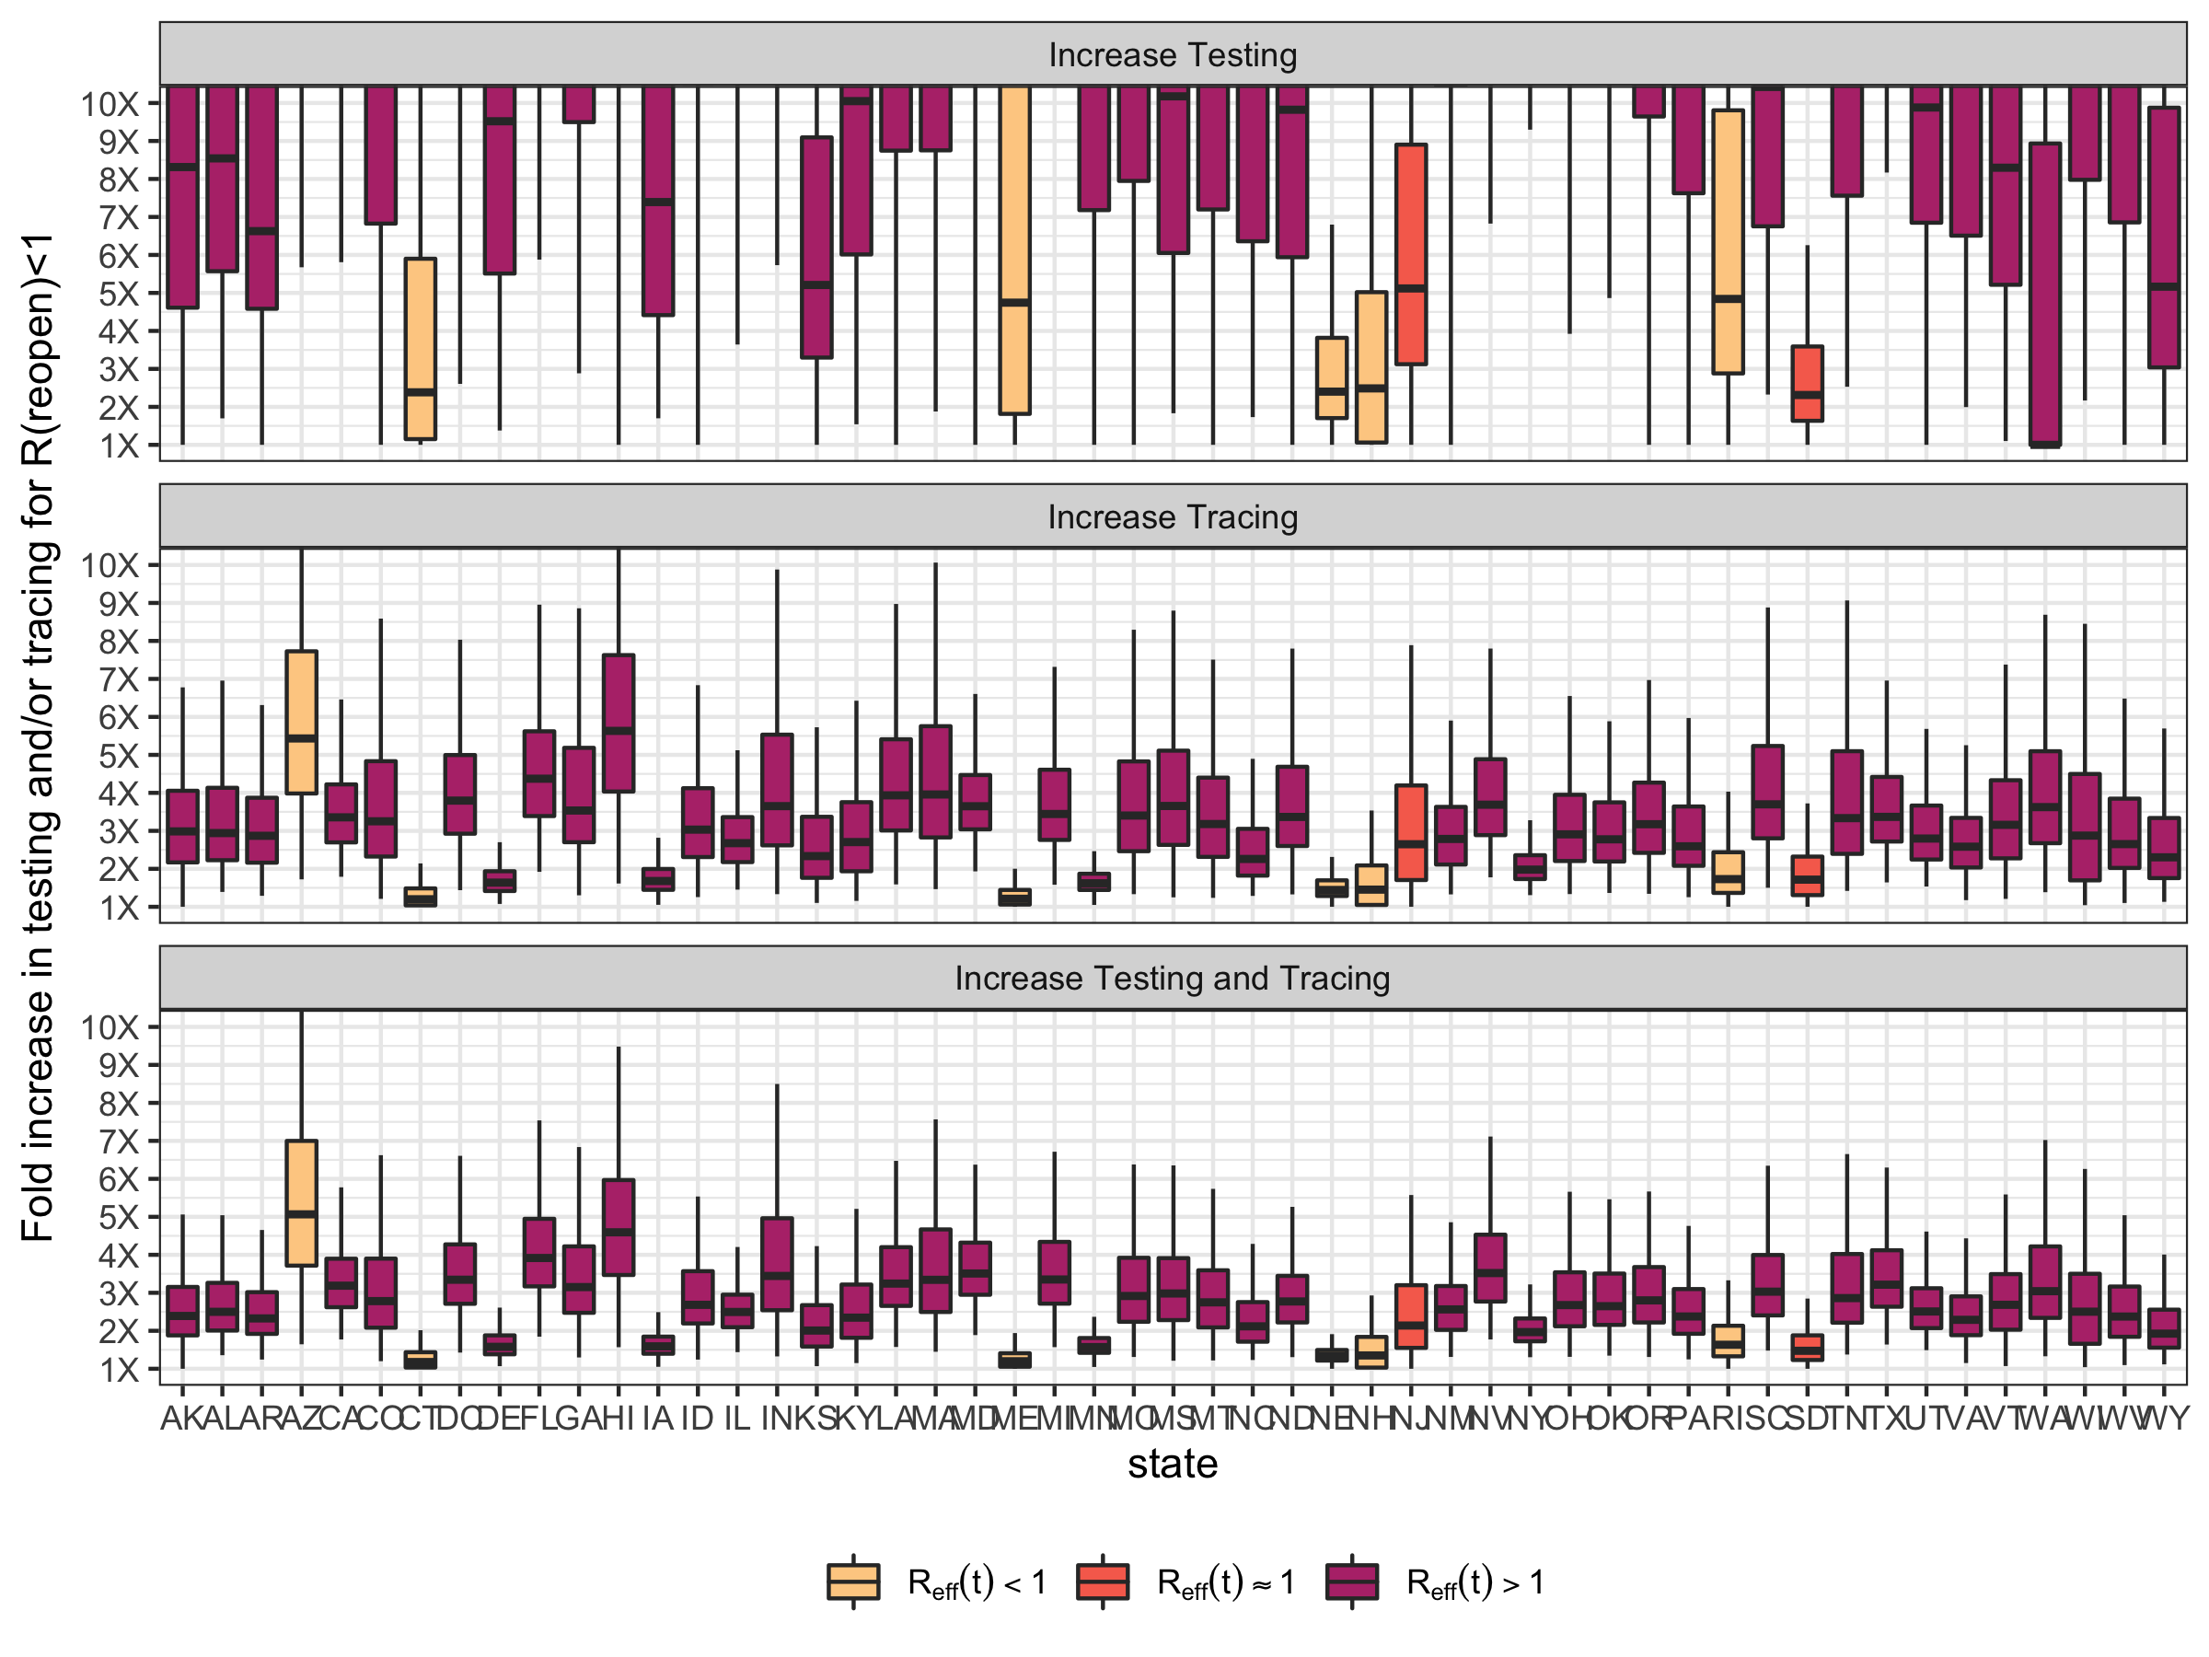

fwrite(as.data.table(tmpdf.quantiles),"RtReopen_TestTraceCritValues.csv")  
ggsave("FigS11_TestingTracingReopen.2020.07.22.pdf",plot=ptesttracereopen,height=4,width=6,scale=1.75)  
ggsave("FigS11_TestingTracingReopen.2020.07.22.jpeg",plot=ptesttracereopen,height=4,width=6,scale=1.75)